dave: of the murphy family  
c/o 123 The Road  
Anytown, The Shire  
[PO5T C0D3]

Council Agent

The Council

Anytown,

The Shire  
PO5T C0D3

20th November 2021

**Notice of Conditional Acceptance**

Dear Mr Willy Sanker,

In the matter of your claim for Council Tax arrears – It has come to my attention that there is no lawful obligation incumbent upon me to pay Council Tax, and that I have mistakenly been paying you in error and in so doing, unknowingly engaging in a crime.

I have become aware that monies raised by Council Tax go, in part, towards military operations in Afghanistan, Iraq, Libya, Somalia and Yemen. I have reasonable cause to suspect that crimes against humanity, war crimes and/or terrorism are or may be being committed by HM Government and HM Armed Forces, as defined in articles 6, 7 and 8 of the International Criminal Court Act 2001. Therefore, if I knowingly continued to contribute to Council Tax, then I would be guilty of committing a crime by aiding and abetting acts of terrorism according to Terrorism Act 2000 section 15(3).

In light of this information, I would be happy to continue paying council tax and settle any arrears due, conditional upon the following: -

* 1. That you can provide the Law, not legislation or an act of Parliament, that obliges me, dave: of the family murphy (the man), to pay Council Tax.
  2. That you can demonstrate that there is a contract between the Council and me, dave: of the family murphy (the man) and not MR DAVID MURPHY (the person and corporation).
  3. That you can demonstrate manifestation of intent by way of my signature on a contract between us.
  4. That the terms and conditions of the contract are lawful.
  5. That council tax is lawful.
  6. That the Council have given full disclosure of the services being offered and that these have been accepted by me.
  7. That you can show where I agreed to contribute toward your council workers’ pension fund, as reported in the Daily Mail Online: (https://www.dailymail.co.uk/news/article-1392908/The-gold-plated-council-pensions-funded-For-time-taxpayer-bears-brunt-premium-costs.html)
  8. That you can show where I agreed to contribute toward the illegal manufacture of cluster-bombs, as reported in the Guardian newspaper on 19th May 2015: (https://www.theguardian.com/world/2015/may/19/uk-pension-funds-cluster-bombs-yemen).
  9. That you can categorically prove that no monies raised by council tax go to fund HM Armed Forces or any military operations in Afghanistan, Iraq, Libya, Somalia and Yemen.

I now require that all of the above conditions be met and presented in Affidavit format sworn under oath or attestation, under penalty of perjury and upon your full commercial liability. If I do not receive such a response conforming to the above criteria within ten (10) days of the date of this letter, it will be deemed a tacit agreement by your acquiescence that I have no obligation to pay Council Tax and that it would be illegal for me to contribute to Council Tax revenues.

Furthermore, if you cannot provide me with the information I have requested, I will be seeking a full refund of all payments previously made.

Yours sincerely - without ill-will, vexation or frivolity

By: dave: of the murphy family

All Rights Reserved - Without Prejudice - Without Recourse - Non-Assumpsit

Errors & Omissions Excepted

Enc: Guardian Article 19 May 2015

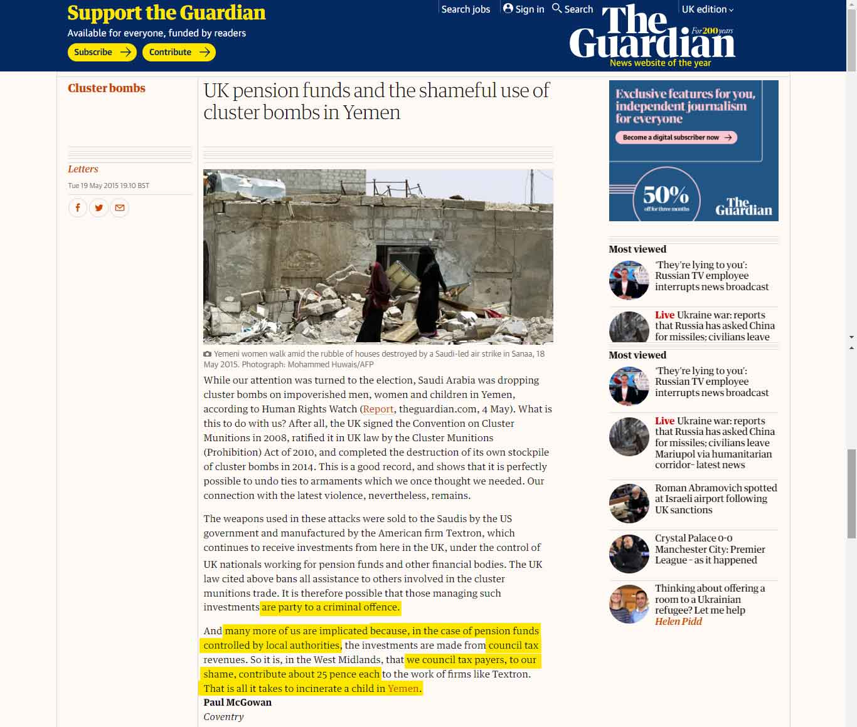

<https://www.theguardian.com/world/2015/may/19/uk-pension-funds-cluster-bombs-yemen>

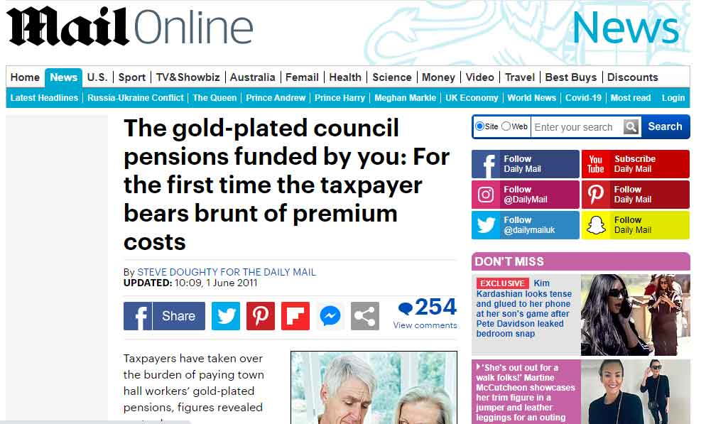

<https://www.dailymail.co.uk/news/article-1392908/The-gold-plated-council-pensions-funded-For-time-taxpayer-bears-brunt-premium-costs.html>